**External API Assignment**



Session: 2021 – 2024

**Submitted by:**

Uswa Arif

2021-CS-77

**Submitted To:**

  Aatif Hussain

Department of Computer Science

**University of Engineering and Technology**

**Lahore Pakistan**

**Introduction:**

**API:**

APIs (Application Programming Interface) enable seamless data communication among software applications and digital services. APIs allow the interaction of one application with the other efficiently and are widely used in web applications. APIs have different types: Public, Private, etc. An External or Open API is an API designed for access by a larger population as well as web developers.

**External API:**

External APIs are designed as per the needs of the external partners and third-party developers.  It is also termed as a ****Public**** or ****Open API**** and is available for use by any outside developer or business. Internal developers can use External APIs as well. External APIs make an organization's data and services easily accessible around the world and help developers create new applications.  These Public APIs generally require API Keys and security tokens to access them.

**Use of Third Party Service:**

External APIs can be created by using third-party services with greater power. This ensures a better user experience, enabling businesses to attract a larger audience. These APIs allow organizations to improve their services.

**Assignment:**

I have used Youtube External API.

**Youtube External API:**

The YouTube External API (Application Programming Interface) is a powerful tool provided by YouTube that allows developers to interact with YouTube's features and data programmatically. It enables developers to integrate YouTube functionality into their own applications, websites, and services, offering a wide range of features and capabilities.

**Access and Authentication:**

**API Key:** Developers must obtain an API key from the Google Developers Console to access the YouTube External API. This key is used to authenticate API requests and track usage.

**Implementation:**

1. I have created my frontend using Html and CSS code.
2. I have used youtube external api in Javascript code.

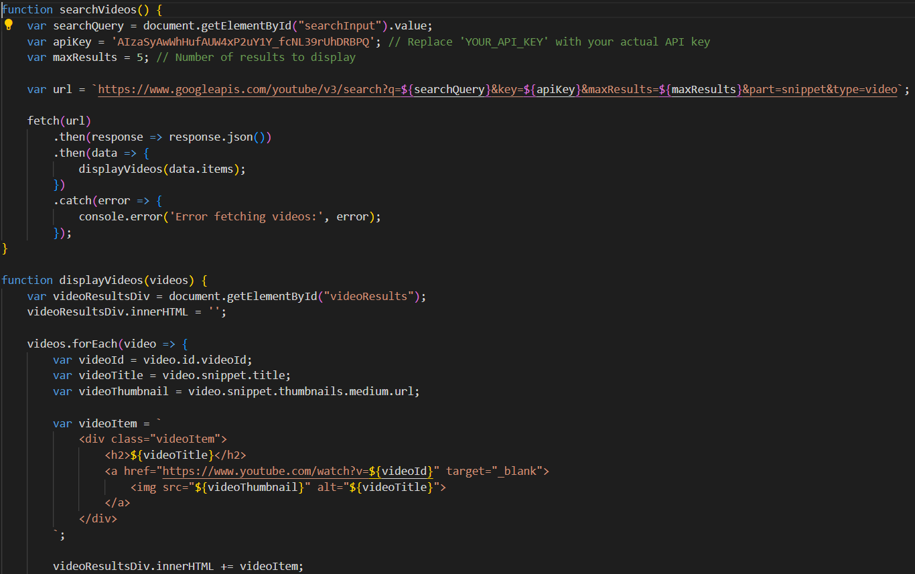

1. The code run as:

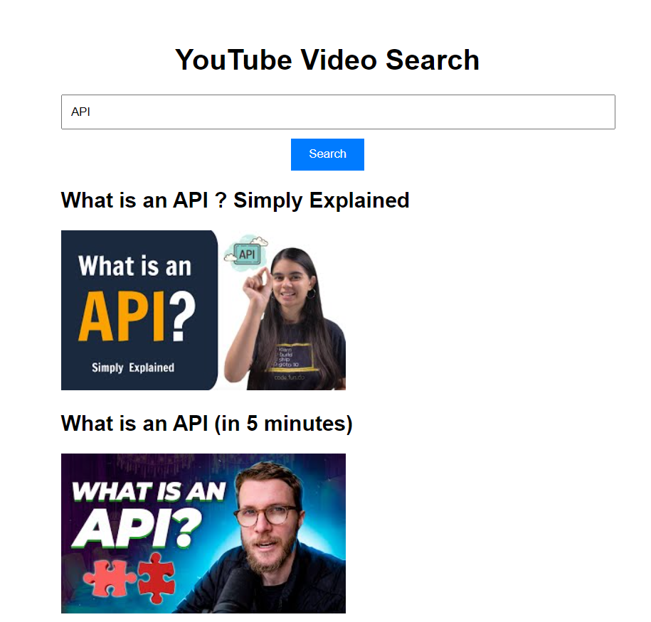

**Conclusion:**

The YouTube External API offers a wide range of features and capabilities for developers looking to integrate YouTube functionality into their applications and services. By providing access to YouTube's extensive library of videos, analytics data, and interaction features, the API enables developers to create engaging experiences and innovative solutions. However, developers must adhere to API usage guidelines, quotas, and authentication requirements to ensure compliance and maintain reliable access to YouTube's resources.